TOUCHLESS ORDER CREATION
Complete Solution Documentation Pack
Live Workshop & Client Sign-Off Edition

Document Type | Technical & Functional Specification + UAT Workshop Pack
Project | Touchless Order Creation — Extraction & Mapping Process
Version | 2.0.1 | Updated Release
Classification | Confidential — For Workshop Use Only
Prepared For | Client Workshop Session — Joint Sign-Off
Date | February 2026

What This Pack Contains
01 Functional Design Specification (FDS) — incl. Business Requirements Checklist
02 Technical Design Specification (TDS)
03 Functional Unit Testing (FUT)
04 Technical Unit Testing (TUT)
05 User Acceptance Testing (UAT) — Live Workshop: Pre-filled answers + client sign-off
06 Training & Maintenance Guide

Table of Contents

01 | Touchless Order Creation Executive Summary

02 | System Architecture & Flow Overview

03 | Functional Design Specification (incl. Business Requirements Checklist)

04 | Technical Design Specification

05 | Functional Unit Testing

06 | Technical Unit Testing

07 | User Acceptance Testing — Workshop Sign-Off

08 | Training & Maintenance Guide

09 | Change Log & New Features

Workshop Note
Section 05 (UAT) is the primary working document for the client session.
The Pre-Validation Checklist (UAT §2) has our system answers pre-filled. The client confirms each item.
All sign-off boxes must be completed before go-live approval is granted.

01 — Touchless Order Creation — Executive Summary
Touchless Order Creation: End-to-End Processing Pipeline

ENVALIOR EXECUTIVE SUMMARY CONFIDENTIAL

Touchless Order Creation
A one-page overview for business stakeholders explaining what the application does, who uses it, what data it requires, and how it is supported.

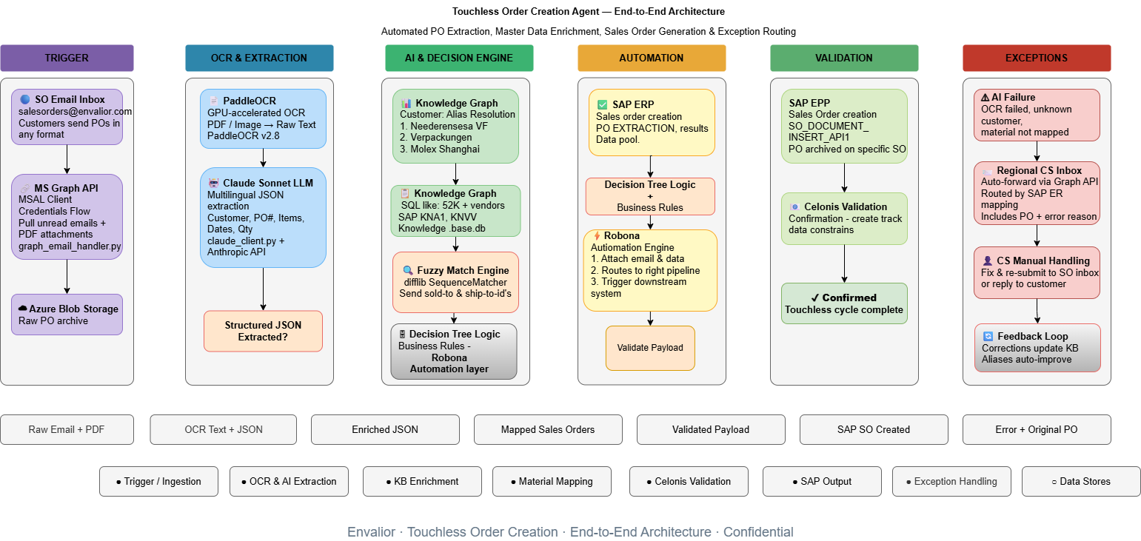
1. Functional Process

The process follows a straight-through pipeline: a customer sends a Purchase Order (PO) by email → the AI engine extracts and validates the data → Celonis applies business rules → a Sales Order is automatically created in SAP. If anything fails, the PO is routed to the regional Customer Service team for manual handling.

2. What the Application Does
The Touchless Order Creation solution automates the conversion of inbound Purchase Orders (POs) into SAP Sales Orders (SOs), eliminating manual data entry. Specifically, it:
- Monitors the central sales inbox (salesorders@envalior.com) for incoming PO emails.
- Extracts key data from PDF attachments using AI (customer name, PO number, materials, quantities, dates).
- Matches the extracted data against SAP Master Data to resolve customer IDs, material codes, and shipping addresses.
- Applies business rules (Sales Organisation, Order Type, SO splitting logic) from an Excel mapping file.
- Sends the validated data to Celonis, which triggers Sales Order creation in SAP EPP.
- Archives the original PO document on the Sales Order in SAP for compliance.

3. Prerequisites
The following must be in place before the application can process POs:
- Azure App Registration — with Mail.ReadWrite and Mail.Send permissions granted by IT for the salesorders mailbox
- Celonis Connection — active Data Pool with write access for the PO_EXTRACTION_RESULTS table
- SAP Master Data — Customer (KNA1), Partner Functions (KNVP), and Material Info Records (KNMT) synced to Celonis
- Excel Mapping File — maintained by the business team with Sales Org, Order Type, Material cross-references, and SO splitting
- rules
- SAP Middleware — Webmethods or equivalent configured for PO document archiving (BAPI integration)

4. Users of the Application
User Role | Interaction
Customers / Buyers Regional CS Team | Send Purchase Orders via email to salesorders@envalior.com. No system access required.
Regional CS Team | Receive exception emails for POs the AI cannot process and handle them manually. Can re-submit corrected Pos.
Master Data Managers | Maintain the Excel mapping file (adding new customers, materials, or rules). No coding required.
IT / DevOps | Monitor the Azure-hosted AI engine, manage API credentials, and handle system updates.

5. Support Model
Level | Responsibility | Handled By
L1 — Business | Failed PO exceptions, customer communication, Excel mapping updates | Regional CS Team
L2 — Functional | New customer onboarding, alias updates, Celonis validation rule changes | Business Analyst / Process Owner
L3 — Technical | AI model issues, API errors, Azure infrastructure, SAP middleware faults | IT / Development Team

6. Data Sources
The application uses the following data from these sources:

Data Source | Update | Frequency
Customer Master (KNA1) | SAP → Celonis Extraction | Daily sync
Partner Functions (KNVP) | SAP → Celonis Extraction | Daily sync
Material Info Records (KNMT) | SAP → Celonis Extraction | Daily sync
Sales Org, Order Type, Material Cross-Ref, SO Splitting Rules | Manual — Excel Mapping File | As needed (managed by business)
Purchase Orders (input) | Customer Email — PDF attachments | Real-time (on arrival)
Customer Aliases | Application — Knowledge Base (SQLite) | Auto-updated via feedback loop
Extraction Results | Celonis — PO_EXTRACTION_RESULTS table | Per PO processed

02 — System Architecture & Flow Overview
Touchless Order Creation: End-to-End Processing Pipeline

1. Introduction
The Touchless Order Creation system operates through a fully automated multi-stage pipeline. Starting from email inbox monitoring through to the generation of SAP-ready Sales Orders, the system integrates multiple components including Microsoft Graph API, Azure cloud services, OCR technology, AI-based extraction, and intelligent matching engines. The architecture diagram below provides a complete visual overview of the data flow.
2. Architecture Diagram

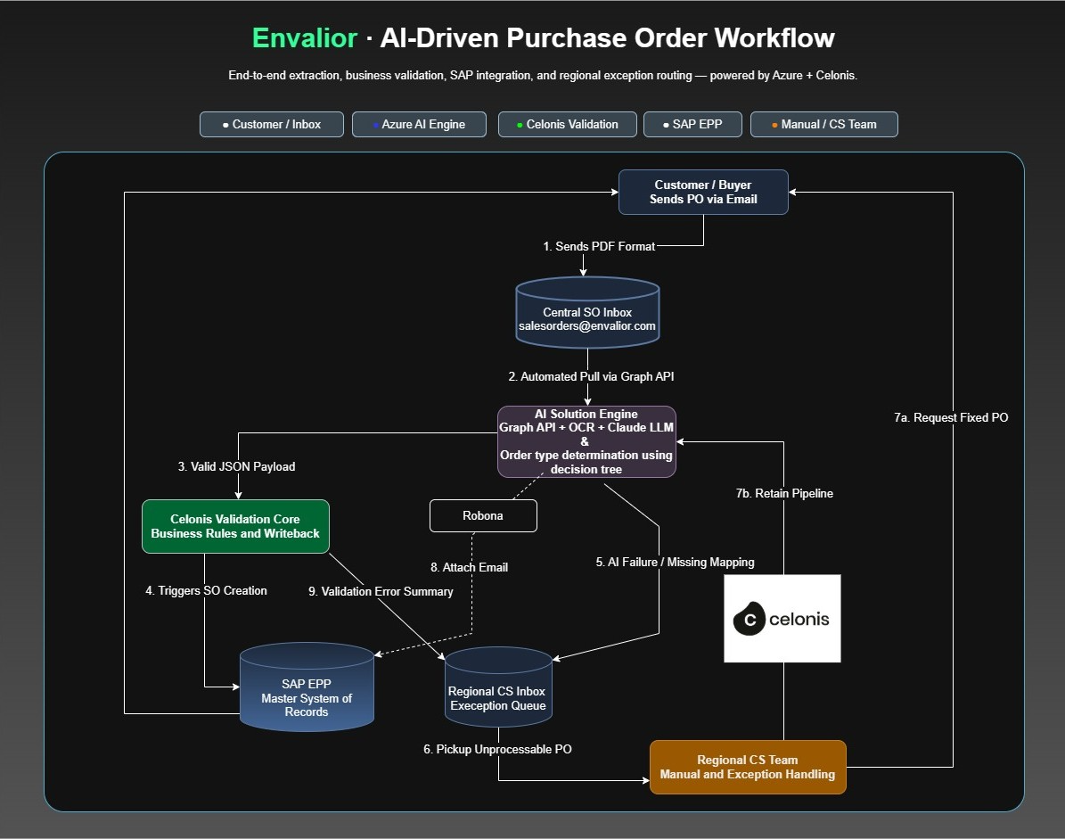

Phase 1: Automated Intake (Happy Path)

- Customer Sends PO: Email is sent to salesorders@envalior.com.
- AI Intake: Azure-based AI Engine polls the inbox via Microsoft Graph API.
- Extraction & Order Type Identification (3 Options):
- Option A: Excel Mapping (Current): The AI uses a manual lookup file to identify TA or KB.
- Option B: Transactional Data (Optional): AI fetches the Order Type from past transaction history. (Note: This is static and won’t capture future changes.)
- Option C: AI Touchless (Recommended): The LLM dynamically infers the Order Type (TA/KB) based on PO context and keywords, enabling truly autonomous capture.
- Celonis Validation: Validates the data against business rules for the identified Order Type.

- SO Creation: Celonis triggers Sales Order creation in SAP EPP.
- Audit Trace: AI attaches the original email source to the SAP SO record automatically.

Phase 2: Exception Handling & Feedback Loop

- AI Failure (Step 5): If AI confidence is low, the PO is routed to the Regional CS Team Inbox.
- CS Manual Review (Step 6): The CS team member reviews the unprocessable PO.
- Resolution Loops (Step 7):
  - 7a (Not Fixable): CS requests a corrected PO from the customer.
  - 7b (Feedback): CS corrections are fed back to improve the AI's classification logic or update the mapping data, increasing future "touchless" success.
- System Feedback (Step 9): Celonis reports any SAP-push validation errors back to the CS team.

3. Architecture Flow Description
The pipeline is composed of seven sequential stages. Each stage is described below, outlining the component involved, its role, and what data it produces or consumes.

Stage 1 — Email Inbox Monitoring (Outlook Inbox)
The pipeline begins at the Microsoft Outlook Inbox, which is continuously monitored for unread emails containing PDF or image attachments. The system polls for new unread messages every 60 seconds, ensuring near-real-time processing of incoming Purchase Orders. Only emails with valid attachments (PDF or image files) are forwarded for further processing.

Stage 2 — Outlook Poller (outlook_poller.py)
The outlook_poller.py script handles authentication and retrieval using the Microsoft Graph API. This component performs two parallel actions upon detecting a qualifying email:
- Pushes a processing message to the Azure Storage Queue (po-processing-queue), signaling that a new PO requires processing.
- Uploads the PDF/image attachment directly to Azure Blob Storage (Container: input-po) for persistent document storage and downstream retrieval.

Stage 3 — Azure Cloud Storage Layer
Two Azure services operate in parallel to enable reliable message-driven processing:
- Azure Storage Queue (po-processing-queue): Acts as the event trigger. When a message arrives in this queue, it fires the downstream OCR processing pipeline.
- Azure Blob Storage (Container: input-po): Stores the raw PDF attachment uploaded by the poller. The OCR engine fetches documents directly from this container for processing.

Stage 4 — PaddleOCR (Optical Character Recognition)
Once triggered by the Azure Storage Queue message, the PaddleOCR engine retrieves the PDF document from Blob Storage and performs Optical Character Recognition. The OCR engine converts the scanned or digitally generated PDF into raw text output, capturing all visible data from the Purchase Order document including header fields, line items, addresses, and material codes. This raw OCR text is then passed to the AI extraction layer.

Stage 5 — Qwen 2.5 3B LLM (Structured JSON Extraction)
The raw OCR text output is processed by the Qwen 2.5 3B large language model, which performs intelligent structured data extraction. Rather than simple text parsing, the LLM
understands the semantic context of the PO document and extracts key fields into a structured JSON format. The extracted JSON includes:

- Customer / Vendor Name
- Purchase Order Number (PO#)
- Line Items — including material codes, quantities, units of measure, and delivery dates
This structured JSON output is then passed to the enrichment and validation layer.
Stage 6 — Knowledge Base & Excel Mapping (Parallel Reference Sources)
Two reference data sources operate in parallel to enrich the extracted JSON:
- knowledge_base.db (Vendor + Material Master Data): A local SQLite database populated from SAP/Celonis master data tables (KNA1, KNVP, KNMT). This database provides the list of allowed Sold-To IDs, Ship-To IDs, and Vendor Names used during the matching process.
- Excel Mapping File: A flat-file Excel document managed by the business team. It provides Sales Organisation codes, Order Type rules, Customer Material Number cross-references, and Sales Order Splitting Rules (X or O) on a per-customer basis.

Stage 7 — Fuzzy Match Engine (Sold-To / Ship-To Validation)
The Fuzzy Match Engine receives both the extracted JSON from the LLM and the allowed IDs and Vendor Names from the knowledge base. Using fuzzy string matching algorithms (fuzz.token_sort_ratio and fuzz.partial_ratio from the TheFuzz library), it resolves:
- Sold-To Party: Matched from the filename metadata or fuzzy-matched from the extracted Vendor Name against the KNA1 master data.
- Ship-To Party: Fuzzy-matched from the extracted delivery address against KNVP Ship-To records linked to the resolved Sold-To.
The output of this stage is an Enriched JSON with fully validated and resolved Sold-To and Ship-To IDs. Records that cannot be matched above the confidence threshold are flagged with review_required: true and routed to a manual review queue.

Stage 8 — Sales Order Builder (Grouping & Routing Logic)
The Sales Order Builder component receives the Enriched JSON (with validated IDs) and the Excel Mapping File data (with Sales Org, Order Type, Customer Material numbers, and SO Splitting Rules). It applies the business-configured grouping logic:
- Rule X — One SO per PO: All extracted line items are consolidated into a single Sales Order.
- Rule O — Separate SO per PO Line: Each individual line item is segregated into its own distinct Sales Order.
The builder maps Customer Material Numbers to Internal SAP Material Numbers, assigns the correct Sales Organisation and Order Type, and groups line items accordingly. The output is a set of Mapped & Grouped Sales Orders ready for SAP ingestion.

Stage 9 — Generated Sales Orders (Ready for SAP / ERP)
The final stage produces the fully structured, SAP-ready Sales Orders in JSON format (final_output.json). These are ready for pickup by the Celonis Action Flow webhook, which posts
them into the SAP ERP system for Sales Order creation. At this point, manual data entry is completely eliminated and the touchless cycle is complete.

Decision Tree for order type Confirmation
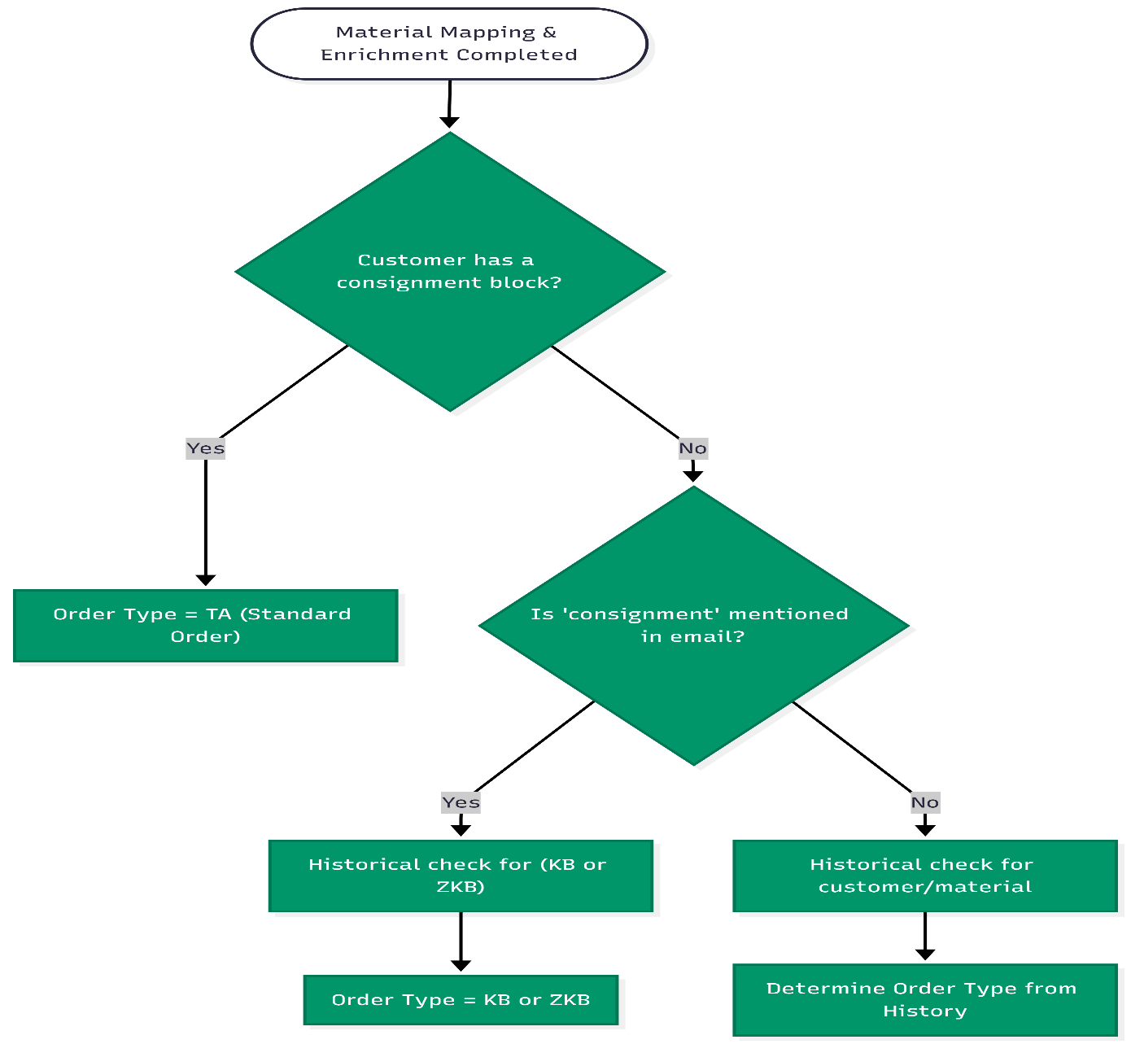

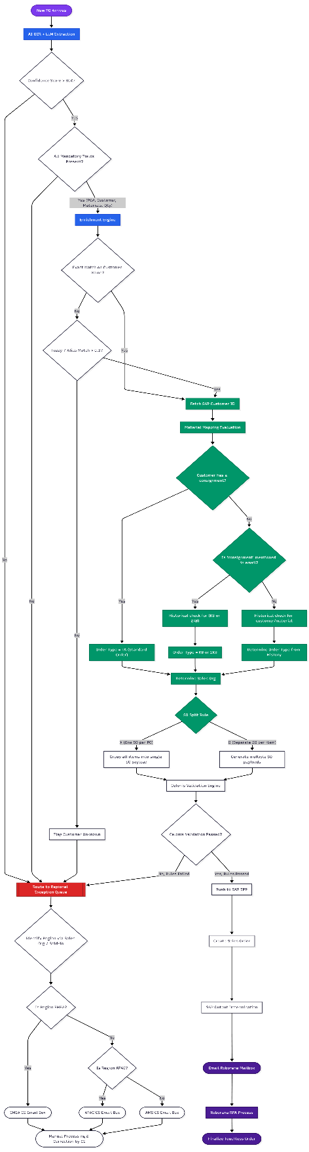

4. Architecture Component Summary

Component | Technology | Role
Email Source | Outlook Inbox | Entry point; monitors for unread emails with PDF/image attachments every 60 seconds
Email Poller | graph_email_handler.py (MS Graph API + MSAL) | Authenticates via Client Credentials Flow using MSAL, retrieves unread emails with PDF attachments from salesorders@envalior.com, triggers the processing pipeline, and handles archiving and exception routing based on extraction success or failure.
Message Queue | Azure Storage Queue (po-processing-queue) | Event-driven trigger to initiate OCR processing pipeline
Document Storage | Azure Blob Storage (Container: input-po) | Persistent storage for raw PO PDF/image attachments
OCR Engine | PaddleOCR | Converts PDF/image documents to raw text for AI extraction
AI Extraction | Claude 4 Sonnet (Anthropic API) | Extracts structured JSON from raw OCR text (Customer Name, PO Number, Line Items, Quantities, Dates) using advanced multilingual LLM capabilities. Handles German, Chinese, Spanish, and other global PO formats natively.
Master Data DB | knowledge_base.db (SQLite) | Stores Vendor and Material Master Data from SAP/Celonis (KNA1, KNVP, KNMT)
Business Rules | Excel Mapping File | Defines Sales Org, Order Type, Material cross-refs, SO splitting rules
Matching Engine | difflib SequenceMatcher + Customer Alias System | Resolves Sold-To and Ship-To IDs using fuzzy string matching (difflib.SequenceMatcher), supplemented by a Customer Alias dictionary that maps known variations (e.g., "Niederwieser" → "VF Verpackungen GmbH", Chinese entity names for Molex). Supports case-insensitive, startswith, and reverse-prefix matching.
SO Builder | Sales Order Builder | Groups line items and applies SO splitting rules (X or O)
Output | Generated Sales Orders JSON | Final SAP-ready Sales Orders for Celonis Action Flow / ERP ingestion

03 — Functional Design Specification (FDS)
Touchless Order Creation: Extraction & Mapping Process

1. Introduction
The Touchless Order Creation process automates the conversion of inbound Sales Purchase Orders (POs) received via PDF or email into SAP Sales Orders (SOs), eliminating manual data entry and reducing order-processing cycle time. This FDS specifies the functional requirements for the data mapping phase, which executes immediately after OCR extraction.

2. Process Overview

# | Stage | Description
1 | Extraction | PO PDFs are processed via OCR/AI to extract header + line-item fields: PO Number, Vendor Name, Material Code, Quantity, Ship-To Address.
2 | Master Data Matching | Extracted Vendor Name/ID matched against Customer Master Data (KNA1/KNVP) to resolve SAP Sold-To and Ship-To Customer Numbers.
3 | Business Rule Mapping | Sales Organisation, Order Type, Internal Material Number, and SO Grouping Rule enriched via the predefined Mapping Table (Excel/DB).
4 | Order Structuring | Line items grouped into SAP Sales Orders per the per-customer SO Grouping Rule (X or O).

3. Functional Requirements

3.1 Customer Resolution (Sold-To & Ship-To)
- Primary Matching: The system reads the Sold-To ID directly from the file naming convention when present.
- Fuzzy Matching: When ID is absent, fuzzy logic matches the extracted Vendor/Customer name against the Master Data table.
- Ship-To Resolution: Multiple Ship-To addresses trigger fuzzy matching against the OCR-extracted address. Low-confidence results default to the primary Ship-To and are flagged for manual review.

3.2 Material Mapping

- Once Sold-To ID is resolved, the extracted Customer Material Number is looked up via the Customer Material Info Record (KNMT).
- The system maps Customer Material Number to the corresponding Internal SAP Material Number.

3.3 Organisational Data & Order Type
- Based on resolved Customer ID, the system maps the correct Sales Organisation and Order Type.
- Both fields are mandatory for successful SO creation in SAP.

3.4 Sales Order (SO) Grouping Logic

Rule | Name | Behaviour
X | One SO per PO | All extracted line items consolidated into a single Sales Order.
O | Separate SO per PO Line | Each extracted line item segregated into its own individual Sales Order.

4. Data Sources and Ownership
- Knowledge Base (Celonis/SAP): Provides baseline Master Data — KNA1, KNVP.
- Mapping Excel: Managed by business owners; defines custom rules for Sales Org, Order Type, Material cross-reference, and SO Grouping Rules.

5. Exception Handling
Exception Rules
Records failing fuzzy-match thresholds are routed to a manual review queue — bypassing automatic enrichment.
Unmapped Customer Material Numbers are explicitly flagged for human validation, preventing erroneous SAP entries.

6. Business Requirements Checklist
The following 12 items confirm how each standard business requirement is addressed natively by this solution. This checklist is the source of truth for the UAT Pre-Validation session.

# | Business Requirement | How the System Addresses It
01 | Sold-To Party (SP number) | Found in filename metadata (e.g., Sold-to 4020000777) OR derived via fuzzy matching the OCR Vendor Name against the vendors (KNA1) database.
02 | Ship-To Party (SH number) | Delivery address extracted from PO; fuzzy-matched against Ship-To addresses linked to the Sold-To (KNVP). If no confident match, default Ship-To is applied and flagged for CSR review.
03 | Bill-To Party (BP number) | Bill-To is inherently linked to the Sold-To in standard SAP configuration. Not overridden by the script — SAP resolves it on SO creation.
04 | PO Date & Format | PO Date extracted by OCR engine. If absent, SAP default behavior (today's date) applies downstream.
05 | Duplicate Order Handling | Duplicate checking (repeated PO number for same Sold-To) handled downstream by Celonis Action Flows and SAP standard warning/error triggers. Not blocked at the mapping stage to preserve auditability.
06 | Multi-Line-Item POs | Controlled via Excel SO Grouping Rule: X = one SO for all line items; O = one SO per individual line item.
07 | Material Identifier(s) | OCR extracts Customer Material Number. Script checks Excel Material Mapping; if matched, maps to Envalior Internal Material. If not, raw text is passed and flagged for human review.
08 | Order Type | Explicit order type (e.g., OR, ZKB) declared per customer in Excel rules mapping file and automatically mapped to output JSON.
09 | Requested Delivery Date(s) | Extracted by OCR from the PO at header level (from first item) and item level. Passed as extracted; parsed by Celonis/SAP downstream.
10 | Pricing Date | Pricing date mechanism remains in SAP. Mapping script does not force a value — relies on downstream standard configuration based on RDD and order type.
11 | Order Quantity & Format | Extracted per line item. normalize_quantity_european engine converts European formats (e.g., 5.000,00 → 5000.00). MT-to-KG conversions enforced via SAP material master.
12 | Unit of Measure | UoM extracted natively via OCR alongside quantity. If missing, regex repair algorithms (e.g., Stebro repair) attempt recovery from raw text. Otherwise SAP defaults are used.

04 — Technical Design Specification (TDS)
Touchless Order Creation: Extraction & Mapping Process

1. Introduction
This TDS defines the architectural and technical implementation details of the mapping module. It documents data structures, relationship keys, algorithms, and all dependencies required to convert extracted PO data into SAP-ready SO data.

2. System Architecture
Component | Details
Language / Runtime | Python 3.x
Core Script — Enrich | enrich_results.py — Standardises extracted JSON against Master Data
Core Script — Sync | setup_knowledge_base.py — Pulls data from Celonis via PyCelonis API
Database | Local SQLite (knowledge_base.db) or Azure PostgreSQL
Mapping File | Flat-file Excel — overrides business rules (Sales Org, Order Type)
Key Libraries | Pandas · SQLAlchemy · TheFuzz (fuzzy string matching)

3. Data Models & Relationships

3.1 SAP Source Tables (Celonis Extraction)
Table | Name | Purpose
KNA1 | Customer Master Data | Sold-To and Ship-To base information.
KNVP | Customer Partner Functions | Bridges relationships; defines Ship-To nodes (PARVW = 'WE').
KNMT | Customer-Material Master | Links Customer Material Numbers to Internal Material Numbers.

Key Relationship Joins
KNA1.KUNNR = KNVP.KUNNR [where PARVW = 'WE'] → Resolves Ship-To nodes
KNVP.KUNN2 = KNA1.KUNNR → Resolves Ship-To Customer ID
KNA1.KUNNR = KNMT.KUNNR → Resolves Customer Material Info Record

3.2 Local Database Schema
Table: vendors
- customer_number (TEXT) — Core identifier
- name (TEXT) — Normalised Customer Name
- sold_to (TEXT) — SAP Sold-To ID
- ship_to (TEXT) — SAP Ship-To ID
- ship_to_name (TEXT) — Name corresponding to Ship-To ID

Table: materials
- customer_number (TEXT) — FK to vendors
- material_id (TEXT) — Internal Material ID
- customer_material_number (TEXT) — Extracted Customer Material ID
- sales_org (TEXT) — Sales Organisation code

4. Technical Workflows & Algorithms

4.1 Vendor Identification (enrich_results.py)
- Filename Parsing: Regex r'[Ss]old-?[Tt]o\s+(\d{7,12})' scans the filename. Match overrides all fuzzy thresholds.
- Fuzzy Name Matching (fallback): Noise words (GmbH, LLC, Corp) stripped; fuzz.token_sort_ratio and fuzz.partial_ratio applied against ALL_VENDOR_NAMES memory cache.

4.2 Ship-To Selection Algorithm
- Aggregates all ship_to_options linked to resolved Sold-To customer_number.
- len == 1: Static assignment.
- len > 1: Fuzzy match against OCR-extracted Ship-To address string; minimum confidence threshold > 0.3.

4.3 Excel Business Rule Mapping
- mapping[cust_id] → { sales_organization, order_type, so_grouping_rule }
- material_map[(cust_id, cust_mat_code)] → { internal_material }

4.4 SO Grouping Strategy (generate_so_groups())
- Rule 'X': All line_items appended into one structured dictionary node.
- Rule 'O': Each line item creates an individual node, ensuring 1:1 SO mapping.

5. Deployment & Execution
Pipeline Execution
Cron-based scheduler triggers: run_ocr_batch.py → enrich_results.py
Output: final_output.json — ready for Celonis Action Flow webhook pickup.

05 — Functional Unit Testing (FUT)
Touchless Order Creation: Mapping Module

1. Introduction
This FUT document outlines functional tests validating the data logic behaviour of the mapping and enrichment phase. Each test case targets a specific functional requirement from the FDS.

2. Test Cases

TC ID | Objective | Input | Expected Output | Pass?
TC_FUT_01 | Sold-To ID from filename overrides fuzzy matching. | Filename: "Order_Sold-to 4020000777.pdf"; Extracted Vendor: "Random Company LLC" | sold_to_id = 4020000777
TC_FUT_02 | Fuzzy match connects OCR vendor name to DB record. | Extracted: "Ecoform Inc"; Master Data: "Ecoform GmbH" (ID: 10001) | sold_to_id = 10001
TC_FUT_03 | Single Ship-To auto-assigned without fuzzy logic. | Sold-To 10001 has exactly one Ship-To 50001. | ship_to_id = 50001; method = single_option
TC_FUT_04 | Correct Ship-To chosen from multiple options via fuzzy. | Sold-To 10001 has 50001 (Berlin) & 50002 (Munich). Extracted: "München Strasse 10" | ship_to_id = 50002; method = fuzzy_match
TC_FUT_05 | Multiple PO line items produce one SO (Rule X). | PO with 3 line items; Excel rule = X | Single Sales Order containing 3 line items
TC_FUT_06 | Multiple PO line items split into separate SOs (Rule O). | PO with 3 line items; Excel rule = O | 3 individual Sales Orders, 1 line item each
TC_FUT_07 | Customer Material Number cross-referenced to Internal. | Customer 10001; Extracted: "MAT-99"; Excel maps MAT-99 → INT-001 | internal_material = INT-001

Tester Note
Mark the Pass? column with P (Pass), F (Fail), or B (Blocked) during testing.
Any Fail must be logged with a defect reference before proceeding to UAT.

06 — Technical Unit Testing (TUT)
Touchless Order Creation: Mapping Module

1. Introduction
This TUT document verifies backend technical execution of the Python scripts — assessing database connectivity, error handling, and algorithmic correctness.

2. Test Cases

TC ID | Objective | Input | Expected Output | Pass?
TC_TUT_01 | Celonis API sync builds SQLite DB correctly. | Delete knowledge_base.db; run setup_knowledge_base.py | DB created; vendors + materials tables populated; schema matches KNA1/KNVP/KNMT
TC_TUT_02 | Missing Excel mapping file handled gracefully. | Rename/delete EXPORT_*.XLSX; run enrich_results.py | Warning: "Mapping Excel not found" logged; no unhandled exceptions raised
TC_TUT_03 | European quantity regex overrides flawed line-item. | Mock JSON: Stebro vendor; raw text contains "700,00 KG" | 700,00 identified; comma replaced; line item overridden with 700.00
TC_TUT_04 | generate_so_groups() serialises output correctly. | Pass 2 PO JSONs: one Rule X, one Rule O | Correctly flattened list; no pointer duplication; sequential SO- IDs generated

Tester Note
Mark the Pass? column with P (Pass), F (Fail), or B (Blocked) during testing.
TUT failures must be resolved by the development team before UAT can commence.

07 — User Acceptance Testing (UAT)
Live Workshop Document — Joint Team & Client Session

How to Use This Document in the Workshop
This document is used JOINTLY by our team and the client in a live session.
Section 2 (Pre-Validation Checklist): Our system answers are pre-filled. The client reads each answer and confirms it matches their business expectation — or raises a gap.
Section 3 (Scenarios): Both teams execute the test scenarios together, step by step.
Section 4 (Sign-Off): The client representative signs after all items are confirmed.
Gaps or disagreements must be logged in the Notes column — they become action items.

1. Prerequisites
Pre-condition | Confirmed by Us | Confirmed by Client
OCR processing pipeline is functional and accessible. | ☐ | ☐
knowledge_base.db has been refreshed with today's SAP data. | ☐ | ☐
Mapping Excel is placed in the designated processing directory. | ☐ | ☐
Test PO PDFs have been prepared for each scenario. | ☐ | ☐
Client stakeholders with business knowledge are present. | ☐ | ☐

2. Pre-Validation Business Checklist
Our team walks through each requirement below. For each item: (1) we explain how the system handles it, (2) the client confirms or raises a gap, (3) the status is marked.

Legend | ✔ Confirmed = Client agrees with our answer | ✘ Gap Found | Gap = Difference from client's expectation — must be resolved before go-live

# | Business Question | Our System Answer (Pre-filled) | Client Confirms?✔ / ✘ | Client Notes / Gap
01 | Sold-To Party  Where is the Sold-To party (SP number) found? | Found in filename metadata (e.g., Sold-to 4020000777) OR derived via fuzzy matching the OCR Vendor Name against the KNA1 database. | ☐ Confirmed  ☐ Gap Found | [Notes]
02 | Ship-To Party  Where is the Ship-To (SH number) found? What if no delivery address is provided? | Delivery address extracted from PO and fuzzy-matched against KNVP Ship-To addresses. If no confident match, default Ship-To is applied and flagged for CSR review. | ☐ Confirmed  ☐ Gap Found | [Notes]
03 | Bill-To Party  Where is the Bill-To (BP number) found? What if no invoice address is provided? | Bill-To is linked to Sold-To in standard SAP configuration. Not overridden by this script — SAP resolves it automatically on SO creation. | ☐ Confirmed  ☐ Gap Found | [Notes]
04 | PO Date  Where is the PO date? What format? What if no date is found? | PO Date extracted by OCR. If absent, SAP default behaviour (today's date) applies downstream. Format parsing handled by Celonis/SAP. | ☐ Confirmed  ☐ Gap Found | [Notes]
05 | Duplicate Orders  How is a duplicate defined? What happens when one is detected? | Duplicate checking (repeated PO number for same Sold-To) handled downstream by Celonis Action Flows and SAP warnings/errors. Not blocked at mapping stage to preserve auditability. | ☐ Confirmed  ☐ Gap Found | [Notes]
06 | Multi-Line POs  How are multi-line POs entered? How are line item numbers handled? | Controlled by Excel SO Grouping Rule: X = all items in one SO; O = one SO per line item. PO line item numbers mapped from the document. | ☐ Confirmed  ☐ Gap Found | [Notes]
07 | Material Identifiers  Where are material identifiers found? Which type does the customer send? | OCR extracts Customer Material Number (MATNR_KU). Script cross-references Excel mapping to resolve Envalior Internal Material. Unmatched items flagged for human review. | ☐ Confirmed  ☐ Gap Found | [Notes]
08 | Order Type  What order type is used (OR, KB, ZKB)? How are standard vs consignment orders handled? | Explicit order type (e.g., OR, ZKB) declared per customer in Excel rules mapping file; automatically mapped to output JSON. | ☐ Confirmed  ☐ Gap Found | [Notes]
09 | Delivery Date(s)  Where are RDDs found? What date format? How is the header field RV45A-KETDAT handled? | Extracted by OCR from PO at header (first item RDD) and item levels. Passed as extracted. RV45A-KETDAT handling managed by Celonis/SAP downstream. | ☐ Confirmed  ☐ Gap Found | [Notes]
10 | Pricing Date  What should the pricing date be? How does it differ for OR vs KB/ZKB? | Pricing date left to SAP standard configuration. Script does not force a value. SAP determines it based on RDD and order type — consistent with current EDI behaviour. | ☐ Confirmed  ☐ Gap Found | [Notes]
11 | Order Quantity  Where is quantity found? What format? How is MT to KG conversion handled? | Quantity extracted per line item. normalize_quantity_european converts European formats (5.000,00 → 5000.00). Unit conversions (MT → KG) enforced via SAP material master data. | ☐ Confirmed  ☐ Gap Found | [Notes]
12 | Unit of Measure  Where is UoM found? What if no UoM is indicated? | UoM extracted natively by OCR alongside quantity. If missing, Stebro repair regex attempts recovery from raw text patterns. Otherwise SAP defaults are used. | ☐ Confirmed  ☐ Gap Found | [Notes]

Checklist Rule
All 12 items must be marked Confirmed before proceeding to Scenario testing.
Any Gap Found item must have notes recorded and an action owner assigned.

3. Acceptance Scenarios
Both teams execute each scenario together. Our team operates the system; client team observes and verifies the output against their business expectations.

Scenario 1 — Standard PO Processing (One SO per PO, Rule 'X')

1 | Drop a sample PDF of a Purchase Order from a vendor configured for Rule 'X' into the input folder.

2 | Trigger the automation process and wait for completion.

3 | Open the generated final_output.xlsx (or UI application if applicable).

4 | VERIFY with client: Extracted Vendor maps to the correct Sold-To ID.

5 | VERIFY with client: Correct Sales Organisation and Order Type are populated from the Excel mapping.

6 | VERIFY with client: All line items share the same so_number — confirming they are grouped into one SO.

Result | Our Team | Client
Notes / Observations | ☐ Pass  ☐ Fail | ☐ Accept  ☐ Reject

Scenario 2 — Split Line Items (Separate SO per PO Item, Rule 'O')

1 | Drop a sample PDF configured for Rule 'O' (e.g., a vendor where each item ships to a different factory).

2 | Trigger the automation process.

3 | Open the resulting output file.

4 | VERIFY with client: The PO is split into multiple Sales Orders.

5 | VERIFY with client: Each material line item has a unique so_number.

Result | Our Team | Client
Notes / Observations | ☐ Pass  ☐ Fail | ☐ Accept  ☐ Reject

Scenario 3 — Material Cross-Referencing

1 | Process a PO containing a known Customer Material Number.

2 | Open the Mapping Excel and locate the expected Internal Material for the Customer + Customer Material Number combination.

3 | Compare the final output Internal Material Number against the Excel mapping.

4 | VERIFY with client: The output Internal Material Number exactly matches the Excel configuration.

Result | Our Team | Client
Notes / Observations | ☐ Pass  ☐ Fail | ☐ Accept  ☐ Reject

Scenario 4 — Manual Review Queue Verification

1 | Process a completely unknown PO — vendor name absent from Celonis Master Data and no Sold-To ID in the filename.

2 | VERIFY with client: System flags the entity with "review_required": true.

3 | VERIFY with client: The record is routed to a human operator — no blind SAP posting is attempted.

Result | Our Team | Client
Notes / Observations | ☐ Pass  ☐ Fail | ☐ Accept  ☐ Reject

4. Gap & Action Log
Log any gaps or disagreements identified during the Pre-Validation Checklist or Scenario testing below.

Ref | Description of Gap | Expected (Client) | Action Required | Owner | Due Date
G-01
G-02
G-03
G-04

5. Workshop Sign-Off
Sign-Off Conditions
All 12 Pre-Validation items marked as Confirmed.
All 4 Scenarios marked as Accepted by the client.
All identified gaps have an owner and due date assigned.

 | Our Team Representative | Client Representative
Full Name
Role / Title
Date
Signature
Overall Decision | ☐ Approved for Go-Live  ☐ Conditional Approval  (gaps must be resolved)  ☐ Not Approved | ☐ Approved for Go-Live  ☐ Conditional Approval  ☐ Not Approved

08 — Training & Maintenance Guide
Touchless Order Creation: Mapping Maintenance

Audience
Master Data Managers and Customer Service Representatives (CSRs) who maintain the mapping rules governing Touchless Order Creation.

1. Introduction
The mapping engine relies on two main sources: Celonis Master Data and the Mapping Excel file. This guide covers how to maintain both.

2. Updating Celonis Master Data
Core Customer data (KNA1, KNVP, KNMT) is synchronised daily from SAP into Celonis.

Topic | Guidance
New Customer / Ship-To | Customer and associated Ship-To branches must be created in SAP and visible in the Celonis Data Pool before the OCR engine can recognise them.
Troubleshooting Unmatched Vendors | If the system flags an order with "review_required": true and cannot find a vendor — verify Customer Name spelling in SAP and confirm the Celonis Data Pool has refreshed.

3. Managing the Excel Mapping Rules
The Excel mapping file controls operational rules for Sales Orders. Key columns: Sales Organisation, Customer, Material, Customer Material Number, Order Type, One SO per PO (X/O).

3.1 Adding a New Customer Rule
- Open the Mapping Excel flat file.
- Add a new row.
- In the Customer column, enter the SAP Sold-To ID (e.g., 4020000777).
- Assign the appropriate Sales Organisation (e.g., 1000) and Order Type (e.g., ZOR).
- Set Grouping Rule: X = single SO per PO; O = individual SO per line item.

3.2 Updating Material Cross-References
When a customer orders using their own Customer Material Number (e.g., V123) but SAP expects an Internal Material ID (e.g., MAT-9000):
- Enter the Customer Material Number (V123) in the Customer Material Number column.
- Enter the Internal Material ID (MAT-9000) in the Material column.
- Ensure the correct Sold-To ID is listed in the Customer column.
The system will now automatically translate V123 → MAT-9000 for this customer.

4. Handling Exceptions
When the mapping engine cannot cross-reference a Customer Material Number (missing from SAP KNMT or Excel), the Internal Material field is left blank and raw data is passed through.

Action Required — CSR
Review flagged outputs manually and determine the correct Internal Material ID.
Update the Excel mapping file so the system automates the translation on all future runs.

09 — Change Log & New Features
Touchless Order Creation: New Scope

9.1 LLM Engine Upgrade: Qwen 2.5 → Claude 4 Sonnet
The extraction engine was upgraded from a locally-hosted Qwen 2.5 3B model to the Claude 4 Sonnet model via the Anthropic API. This change provides:
• Significantly improved accuracy on multilingual POs (German, Chinese, Spanish, etc.)
• Better structured JSON output with fewer hallucinations
• Native understanding of complex table layouts and multi-page POs
• Configurable via .env (LLM_PROVIDER=claude, ANTHROPIC_API_KEY)
Files Changed: po_extraction_enhanced.py, claude_client.py (NEW), .env

9.2 Material Mapping Engine Enhancements
The material mapping logic in sales_order_mapper.py was enhanced to handle real-world variations in Customer Material Numbers extracted from POs:
• Case-Insensitive Matching: Extracted "Akulon F130-C2" now correctly matches Excel entry "AKULON F130-C2" (previously failed on strict exact match).
• Startswith Matching: Extracted "111102" now correctly matches Excel entry "111102 OKTABIN" where the Excel value has a suffix descriptor.
• Reverse Prefix Matching (NEW): Extracted "11110201" now correctly matches Excel entry "111102 SILO" by checking if the extracted code starts with the numeric prefix of the Excel Customer Material Number. This handles the common pattern where PO line items append a variant/SKU suffix.
Files Changed: sales_order_mapper.py (lookup method enhanced with 3 fallback tiers)

9.3 Customer Alias & Fuzzy Matching System
A CUSTOMER_ALIASES dictionary was introduced in po_extraction_enhanced.py to handle known variations of customer names that the LLM extracts differently from the canonical KB entries:
• "niederwieser" → "VF Verpackungen GmbH" (Customer ID: 4020000825)
• "mf-folien" / "mf folien" → "MF Folien GmbH" (Customer ID: 4020001301)
• "molex interconnect (shanghai)" → "上海莫仕连接器有限公司" (Customer ID: 4020010375) — Cross-language alias resolution
The fuzzy matching prefix filter was also improved to compare only alphanumeric characters (ignoring hyphens and spaces), resolving issues where "mf-" did not match "mf " in the KB.
Files Changed: po_extraction_enhanced.py (fuzzy_match_vendor, CUSTOMER_ALIASES)

9.4 MS Graph API Email Integration (NEW)
A new module (graph_email_handler.py) is being built to automate the full email lifecycle using the Microsoft Graph API with Client Credentials Flow:

• Authentication: Uses MSAL library with MS_GRAPH_CLIENT_ID, MS_GRAPH_TENANT_ID, and MS_GRAPH_CLIENT_SECRET to obtain a bearer token without user interaction.

• Ingestion: Pulls all unread emails with PDF attachments from salesorders@envalior.com Inbox via Graph API.
• Happy Path (Success): After successful extraction and mapping, the original email is moved to the "Archive" folder via the Graph API /move endpoint.
• Exception Path (Failure): If extraction or mapping fails, the email is moved to Archive AND a new email is sent (via /sendMail) to the Regional CS Email Box with the original PDF attachment and a structured failure summary.
Files Changed: graph_email_handler.py (NEW), .env (MS_GRAPH credentials added)

9.5 Exception Routing & Regional CS Handoff
The updated architecture introduces automated exception routing based on the extraction outcome:
• AI-Level Exceptions: If the AI cannot process a PO (poor quality, unrecognized customer, missing material mapping), the system automatically forwards the original email + PDF + failure reason to the appropriate Regional CS Email Box.
• Celonis-Level Exceptions: If Celonis fails to push the SO to SAP (credit block, validation error, API timeout), an error notification is routed to the CS team.
• AI Feedback Loop: When a CS rep manually corrects a failed PO, the correction can be fed back into the Knowledge Base (CUSTOMER_ALIASES or SQLite DB) to continuously improve the AI pipeline.

9.6 Celonis Data Push Module (NEW)
A dedicated push_to_celonis.py script was created to push the extracted and mapped CSV data directly to the Celonis Data Pool using the pycelonis SDK.
• Connects to Celonis Sandbox (envalior-sb.eu-1.celonis.cloud)
• Appends data to the PO_EXTRACTION_RESULTS table in the configured Data Pool
• Handles table creation as a fallback if the table does not yet exist
Files Changed: push_to_celonis.py (NEW), pipeline_run.py (updated to include Celonis step)

9.7 Robust LLM Field Name Handling
The enrichment logic was updated to handle multiple possible field names that Claude may use for customer and vendor information. The system now checks for:
• vendor_name, supplier_name, customer_name, customer_id, buyer_name
This ensures the fuzzy matching engine is always triggered regardless of which field name Claude uses in its JSON output, reducing silent failures.

9.8 Summary of All Modified Files

File | Type | Key Changes
po_extraction_enhanced.py | MODIFIED | Claude LLM integration, CUSTOMER_ALIASES, fuzzy matching improvements, robust field name handling
claude_client.py | NEW | Anthropic API client wrapper for Claude models
sales_order_mapper.py | MODIFIED | Case-insensitive, startswith, and reverse-prefix matching for Customer Material Number
push_to_celonis.py | NEW | Celonis Data Pool push via pycelonis SDK
graph_email_handler.py | NEW (Planned) | MS Graph API email ingestion, archiving, and exception routing
pipeline_run.py | MODIFIED | End-to-end pipeline orchestration with Celonis push step
.env | MODIFIED | Added MS_GRAPH credentials, ANTHROPIC_API_KEY, LLM_PROVIDER
architecture_presentation.html | NEW | Interactive Mermaid.js architecture diagram for client presentations

